|  |  |
| --- | --- |
| **Theme**​ | **In art**, **theme** is usually about life, society or human nature, but can be any other subject. **Themes** are the ideas explored **in** a work.​ |
| **Emotion**​ | a strong feeling such as joy, hatred, sorrow, or fear. When one feels an emotion, there are physical changes such as an increase in pulse, crying, or trembling.​ |
| **Message**​ | What is the artwork about? What does it mean? The message of an artwork is what you take away from looking at it.​ |
| **Shepard Fairey** | An American contemporary artists, activist and founder of OBEY Clothing |
| **Florain Nicolle** | A French illustrator who has been working as a freelancer since 2009. |
| **Stenciling** | The method of applying a design onto a surface through a cut out overlay. |
| **Identity** | The fact of being who or what a person or thing is |

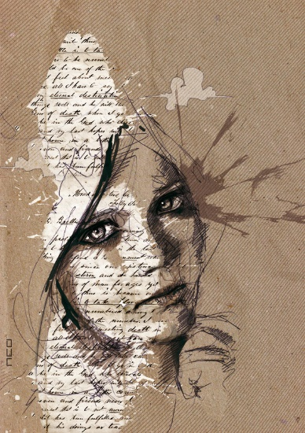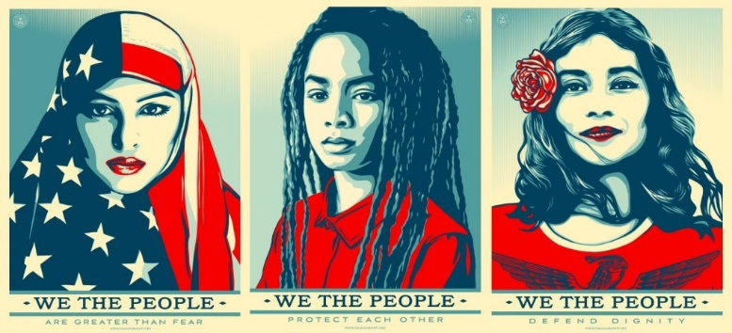

**Explore Identity Art in a variety of ways: pencil, pen, watercolour, coloured pencils, oil pastels, felt pens.**

**You can copy work from the artists Shepard Fairey and Florain Nicolle**

**Create your own self identity portrait using espressive art and text from Florain Nicolle and Shepard Fairey.**

Non-examples

Examples

Characteristics

Definition

Identity

**Year 10 Heroes Project**

**Art and Design**