**Globalisation**

Globalisation is the process by which the world’s local and regional economies, societies, and cultures have become integrated together through a global network of communication, transportation and trade.

Causes include:

1. Improvements in transport – allow people and products to travel around the world easily and quicker than before.
2. Improvements in communications – allow people to connect from different parts of the world within travelling themselves.
3. Freedom of trade – Organisations, such as the World Trade Organisation (WTO) promote free trade between countries.
4. Labour availability and skills – cheaper labour costs and reduced legal restrictions in LIC’s led to labour intensive industries (mainly TNC’s) moving their factories to developing countries.

*TNCs (transnational cooperation) have traditionally had their headquarters in the*Triad*which is made up of the*HICs*(high income countries) in Europe as well as the United States and Japan. Companies in the Triad have had an advantage as many of these countries were once*colonial powers*. Colonial powers grew richer through*exploiting*the*resources*of their colonies. This wealth has enabled large companies to grow.*

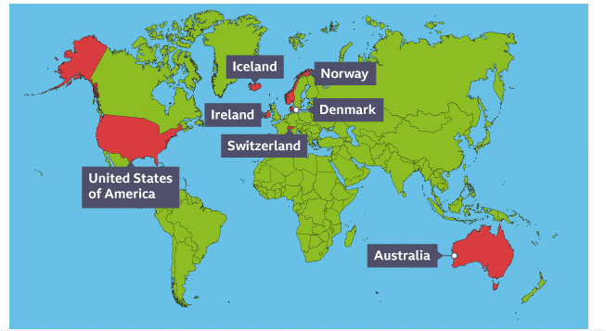

**What is Development?**

Development is an improvement in living standards through the better use of resources.

**Economic** – This is the progress in economic growth through levels of industrialisation and use of technology. **Social** – This is the improvement in people’s standard of living.

**Environmental** – advances in the management and protection of the environment.

**Measuring Development**

Development indicators are used to compare and understand a country’s level of development. **LIC’s** – low income country. **NEE’s** – Newly Emerging Economic. **HIC’s** – High Income Country.

Indicator examples include:

Employment type - % of population working in primary, secondary, tertiary and quaternary sectors

Gross Domestic Product per capita – total value of goods and services produced in a country per person, per year.

Gross National Income per capita – average gross national income per person, per year in $

Infant mortality – number of children who die before reaching 1 years old per 1000 babies born.

Literacy rate - % of people over the age of 15 who can read and write.

Life expectancy – The average lifespan of someone born in that country.

HDI – Human development Index – a number that uses life expectancy, education level and income per person to score a country’s development – more reliable as more variables used.

**Impacts of globalisation**

*Employment – job opportunities have led to economic growth in LICs and NEEs.*

**Deindustrialisation has led to job losses in HIC’s.**

*There is improved across to resources as countries trade with one another.*

**Some resources have been overexploited which means they may run out.**

*Countries rely on one another and are more likely to work together.*

**Manufacturing and transportation can lead to high levels of pollution.**

*Ideas and skills are shared amongst countries and this can lead to higher rates of success.*

**World events, such as pandemics, can leave countries who rely on others struggling and slow development, as trade and tourism declines dramatically.**

**Year 9 – World Development**

**Geography**