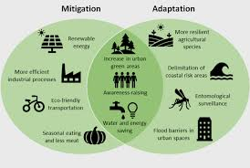

**Desertification** is when fertile land is changed to desert due to a lack of nutrients and a reduction in soil quality.

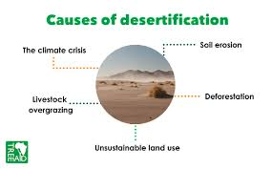

**Impacts:** Plants cannot grow as there is not enough fertile soil, poverty, droughts.

**Solutions:** Afforestation (planting trees).

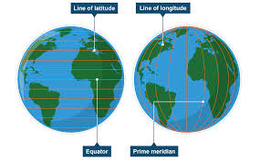 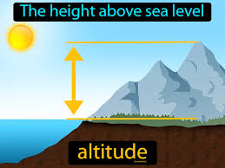

**Factors that affect the UK climate**

**Latitude**

The equator receives the strongest solar energy making it warm. As you travel away from the equator the sun’s energy becomes less concentrated and temperatures become cooler.

**Altitude**

There is a 1°C drop in temperatures for every 100m increase in height.

**Climate –** The average weather over 30 years.

**Weather –** The day-to-day conditions of the atmosphere.

**Temperate –** A region or climate that has mild temperatures

**Strategies to manage climate change**

**Mitigation –** Make something less severe, serious or painful

**Examples –** Afforestation (planting trees) to take in CO2 emissions

**Adaptation –** When you change to fit a new environment

**Examples -** Agriculture - farmers will have to adapt as some crops may not be able to grow in a warmer climate. However, other crops (e.g. oranges and grapes) will be able to be planted.

**UK - Boscastle Flooding (HIC):**

Causes: Over 75mm of rainfall fell in 2 hours, 200mm in one afternoon.

Impacts: 7 helicopters used to rescue people from roof tops, houses damaged, cars swept down stream.

Responses: Flood defence scheme – widen and deepened the river, moved the care park away from the river, added overflow drainage, removed trees and sediment away from bridges so water can flow freely.

**Bangladesh Flooding (LIC):**

Causes: Monsoon rainfall every year

Impacts: houses washed away, crops and farms destroyed, contaminated water sources, people killed.

Response: German Red Cross provided money and plastic containers to help people keep food and water safe from contamination, by seeds to plant after the floods and try to protect their homes.

**Factors affecting the UK climate**

**Ocean currents**

The North Atlantic Drift carries warm water to the western shores of the UK and the prevailing south-westerly winds spread the warmer conditions out, creating a warm and mild winter in the western parts of the country.

**Relief rainfall**

Prevailing winds bring warm, moist air to the western British Isles. Air is forced to rise over high areas and cools and condenses forming clouds. Air descends on the other side of the mountains and it causes it to be warmer and drier.

​

**Year 7 World of Weather**

**Geography**