Genres Through Time  
**Work Songs** – Songs sang in the fields by slaves  
**Blues** – Earliest form of Jazz Music  
**Ragtime** – Fusion of Blues & Marching Music on Piano  
**New Orleans Jazz** – Traditional Jazz Music from Louisiana  
**Jazz** – A wider genre with many different styles  
**Swing** – Features a Big Band and is Notated  
**Bebop** – Extremely fast and often very difficult to play

Keywords & Terms

**O**rnamentation – Playing techniques to make the melody sound more interesting

**M**elody – The main tune

**A**rticulation – Playing techniques which affect the way music sounds

**D**ynamics – The loudness of music

**T**empo – The speed of music

**S**tructure – How a piece of music is put together

**H**armony (Tonality) – The key and mood or emotion of music

**I**nstrumentation (Timbre) – The instruments used in music and their sounds

**R**hythm – The patterns of music

**T**exture – The layers of sound in music

**S**tyle – The genre or expected aspects of a piece of music

Bass Clef – This appears at the start of written music and tells us the correct pitches to play – Left Hand Notes

Treble Clef – This appears at the start of written music and tells us the correct pitches to play – Right Hand Notes

Expression – How a performer adds emotions to a performance

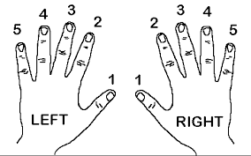

Both Hands Finger Positions on Keyboards

Treble Clef Bass Clef  


Topic Key Learning:

* Using the O-MAD-T-SHIRTS Mnemonic
* Keyboard Layout, Notes & Finger Positions  
  (Both Hands)
* 12 Bar Blues, Ragtime, Jazz Performance Skills
* Performing in an appropriate **style**

C D E F G A B C D E F

Keyboard Layout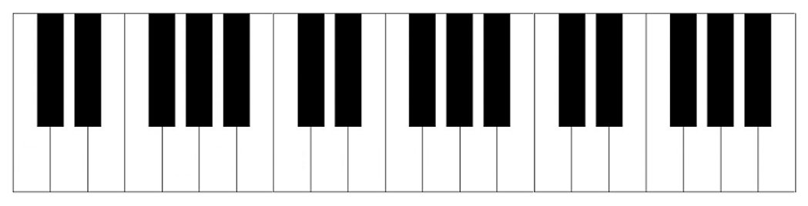

**Year 9 The Blues, American and World Music**



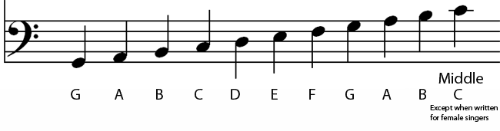

**Music**