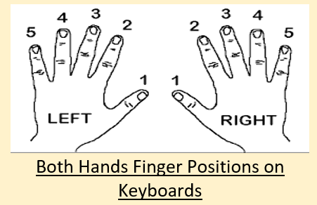

4 “Great Eras” in Music

**Baroque**

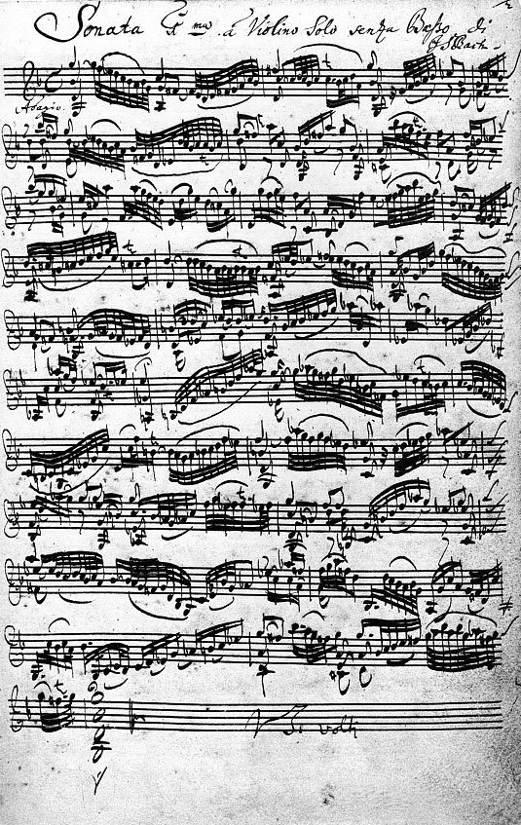

**Classical**

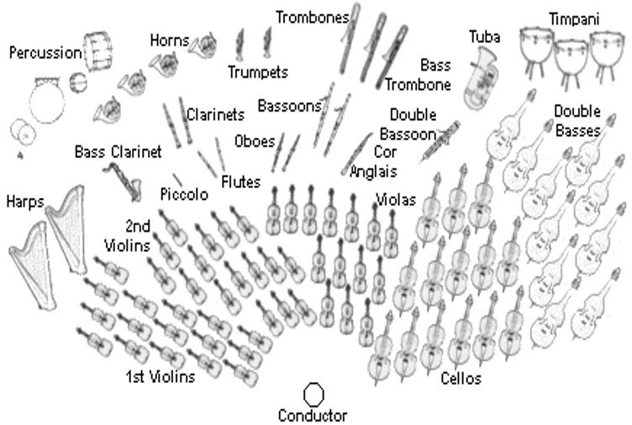

**Romantic**

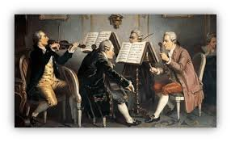

**20th Century**

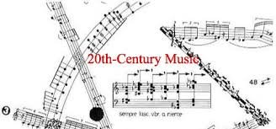

Keywords & Terms

Pitch – How high or low a sound is

Rhythm – The patterns of music

Melody – The main tune

Dynamics – The loudness of music

Tempo – The speed of music

Tonality – The mood or emotion of music

Timbre – The instruments used and how they sound

Bass Clef – This appears at the start of written music and tells us the correct pitches to play – Left Hand Notes

Treble Clef – This appears at the start of written music and tells us the correct pitches to play – Right Hand Notes

Harmony – Playing 2 or more notes together

Topic Key Learning:

* Historical Contexts of Music Through Time
* Western Classical Tradition of Music
* Musical Notation Treble & Bass Clef
* The 4 “Great Eras” of Music

C D E F G A B C

Keyboard Layout Reminder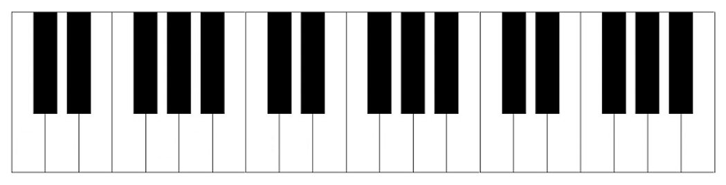

Musical Notes on the Bass Clef

Treble Clef Bass Clef  


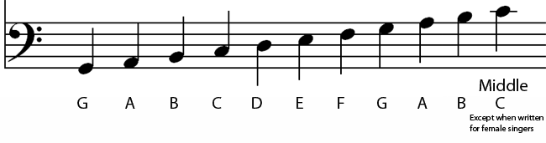

**Year 8 Music Through Time**

**Music**