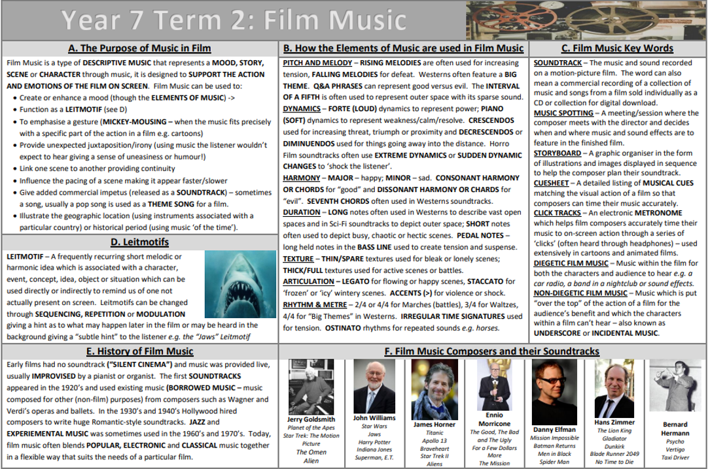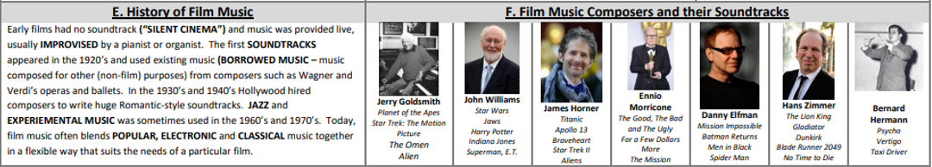

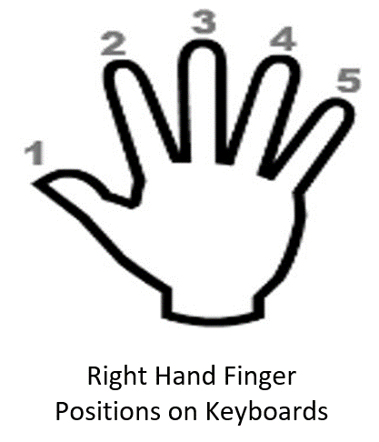

Leitmotif:

* A Leitmotif is music which **represents and expresses** a character, or something within a film, to the audience.
* Like a Theme Song almost

**Pitch & Melody**: **Rising Melodies** are often used for increasing tension. **Falling Melodies** are used for defeat. Western Genre films often feature a **Big Theme** that dominates the soundtrack. **Call & Response** can be used to represent Good Vs Evil. **The Interval of a Fifth** is often used to represent outer space, or Sci-Fi because of its open and sparse sound

**Dynamics:** **Forte (Loud)** dynamics represent power. **Piano (Quiet)** dynamics represent weakness, calm, peace. **Crescendos (Getting Louder)** are used to increasing threat, triumph, or things getting closer. **Decrescendos/Diminuendos (Getting Quieter)** are used for things moving into the distance. Horror films also often use **Extreme Dynamic** changes to scare us.

**Tonality:** **Major** (Happy), **Minor** (Sad), **Unclear** (Evil/Scary)

**Texture: Thin** textures are used for sad and lonely scenes. **Thick (fuller)** textures are used for active scenes, fights and battles

**Rhythm:** **Ostinato (repeated rhythms)** are used commonly to build tension or represent common repetitive sounds (e.g. a horse)

Topic Key Learning:

* Musical Element Uses in Film Music
* Keyboard Performance Skills for Film Music
* Musical Notation Notes & Symbols
* Film Music Composers and notable works

**Film Music Composers**

**Musical Elements in Film Music**

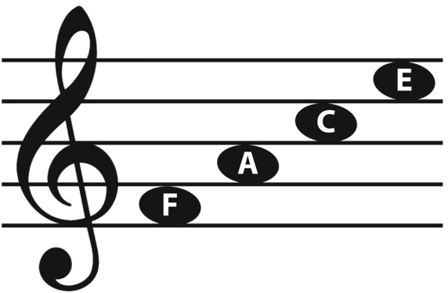

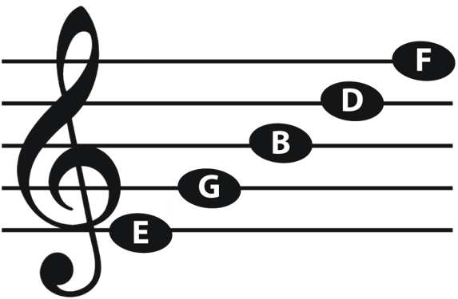

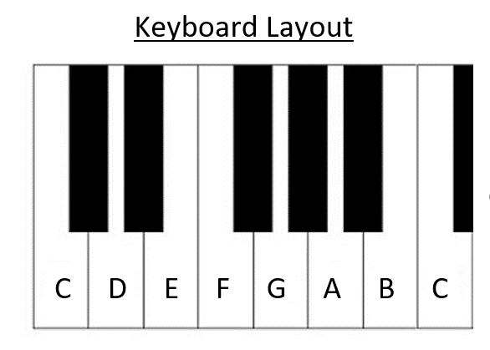

**Year 7 Music for Film**

**Music**