Keywords & Terms

**O**rnamentation – Playing techniques to make the melody sound more interesting

**M**elody – The main tune

**A**rticulation – Playing techniques which affect the way music sounds

**D**ynamics – The loudness of music

**T**empo – The speed of music

**S**tructure – How a piece of music is put together

**H**armony (Tonality) – The key and mood or emotion of music

**I**nstrumentation (Timbre) – The instruments used in music and their sounds

**R**hythm – The patterns of music

**T**exture – The layers of sound in music

**S**tyle – The genre or expected aspects of a piece of music

Bass Clef – This appears at the start of written music and tells us the correct pitches to play – Left Hand Notes

Treble Clef – This appears at the start of written music and tells us the correct pitches to play – Right Hand Notes

Expression – How a performer adds emotions to a performance

Topic Key Learning:

* Using the O-MAD-T-SHIRTS Mnemonic
* Keyboard Layout, Notes & Finger Positions  
  (Both Hands)
* Musical Notation Notes, Clefs & Ornamentation Symbols
* Performing Expressively

C D E F G A B C D E F

Keyboard Layout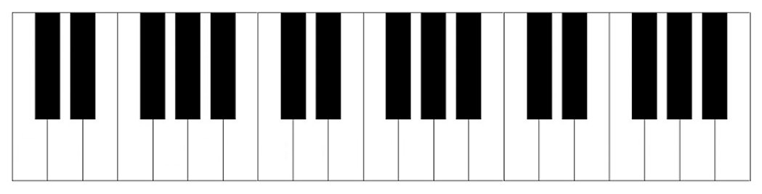

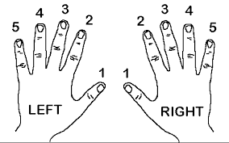

Both Hands Finger Positions on Keyboards

Ornaments & Ornamentation

Grace Note Trill Lower Mordent

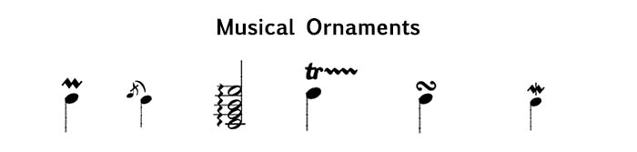

Mordent Arpeggiation Turn

Treble Clef Bass Clef  


**Year 9 Further Understanding & Performing with the Elements**



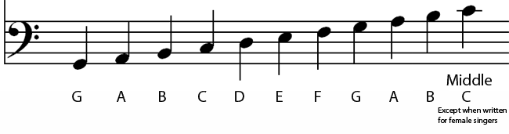

**Music**