**Temperatures-**

The normal body temperature of a human is 37°c.

That is the temperature that our body needs to be to function properly.

**Hypothermia**

Hypothermia is when the body temperature falls to 35°c or less. When this happens the body starts to shiver to increase muscle activity to generate heat.

If the person is in cold water for a while the body temperature continues to fall. The person will start to become confused and will lose coordination so will be unable to swim. Breathing will become more difficult and the swimmer will become unconscious.

If the Casualty’s temperature reaches 30°c they will die.

**Vital organs in the body**

We have four vital organs that we need to protect when we are in cold water. If we don’t keep them warm then they start to shut down

The heart is the key organ in the circulatory system it’s main function is to pump blood throughout the body.

The lungs are the organs that are responsible for gas exchange. The process exchanges oxygen for the waste product carbon dioxide

The liver is the largest organ in your body the main functions of the liver is to make glucose from carbohydrates that you eat for energy and to clean your blood by taking toxins out of it.

Your kidneys are two of the most important organs in your body. They filter your blood and help get rid of waste products from your body

**Straddle Jump**

The purpose of a straddle jump is to not get your head wet. This is very important in personal survival as we lose the most heat from our head.

To do a straddle jump you must

* Hold your arms out to the side
* Look up
* Take a big step forward
* Have no straight limbs
* As you enter the water push forward and up (scooping action) with your arms

**H.E.L.P position -**

To protect our body’s vital organs we must keep them warm. To do this we can take up the H.E.L.P position in cold water.

To do this you need to find an object that floats. You lie on your back and place the object on your chest. You then have to bring your knees up to reduce your size and the amount of surface area visible. This will stop the heat from escaping from your body.

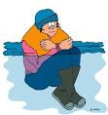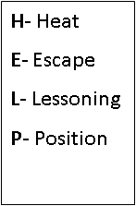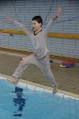

**Year 8 Personal Survival**

**PE**