**Shoulder Pass**

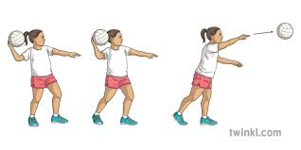

1. Control the ball with both hands, placing it above your shoulder, then remove the supporting hand.

2. Fingers should be spread behind the ball.

3. Feet should be should width apart.

4. Bring the ball back, bending your elbow.

5. Bring the arm forward, following the ball through until your arm and fingers are in front of you, in the direction you want the ball to travel.

6. As you bring your arm forward, step forward with the opposite foot to the arm you are holding the ball in,

**Rules**

Contact: You cannot touch or push any player during the game. This will result in a penalty pass, or penalty shot if you are in the circle, to the opposition.

Footwork: If the player moves their landing foot or takes steps with the ball, the opposition get a free pass.

Obstruction: You must be at least 1 metre away from the player from the opposite team with the ball before you mark or defend the ball. This will result in a penalty pass, or penalty shot if you are in the circle, to the opposition.

Held Ball: You can only hold the ball for 3 seconds before you pass or shoot.

Repossession: If a player drops the ball, or bounces the ball, and picks it back up again, the opposition get a free pass.

**Shooting**

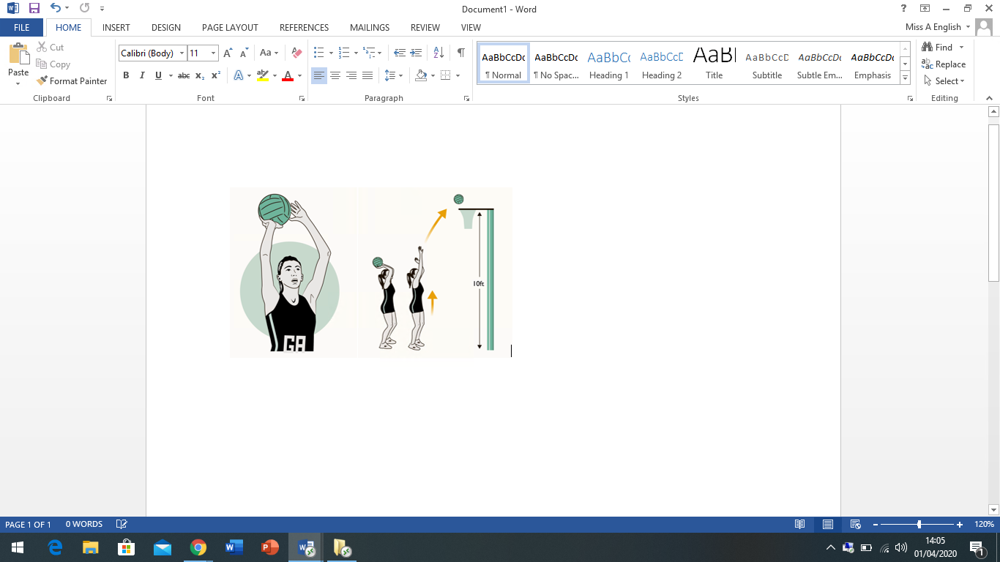

1. Rest the ball on your preferred shooting hand with the other hand supporting on the side.

2. Feet should be shoulder width apart.

3. Look at the back of the ring.

4. Bend your knees, lift your heels off the floor and push the ball up and over the top of the ring to loop into the net.

**Chest Pass**

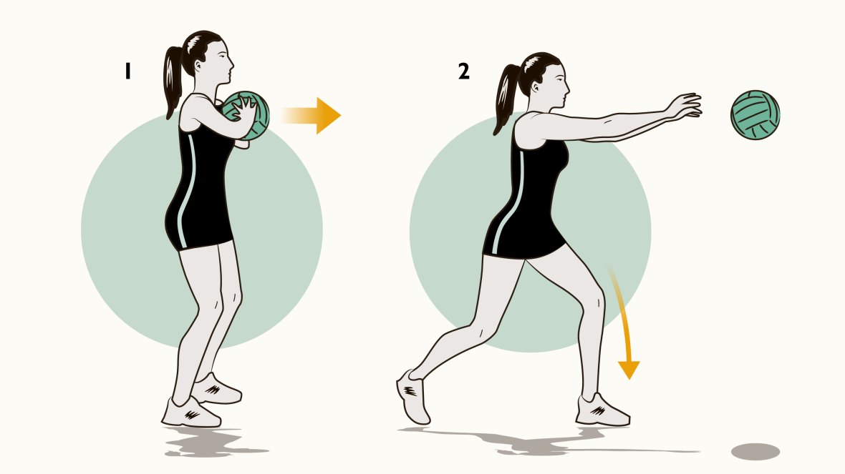

1. Thumbs and index fingers form a W shape. The remaining fingers should be spread behind the ball to push it away.

2. Elbows should be kept low and close to the body. Feet should be shoulder width apart.

3. Keep the ball close to your chest.

4. Fingers facing forward, push the ball towards to the chest of the receiver to create a flat, strong pass.

5. As you push the ball forward, step forward with one foot.

**Year 7 Netball**

**PE**