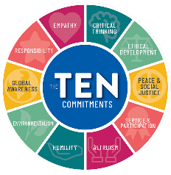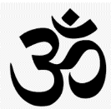

**What do Humanists believe?**

They believe it is possible to live a good and fulfilling life without following a traditional religion. They do not follow a holy book. Instead, Humanists value traits like reason and rely on science to explain the way things are. They believe that people have one life to live - there is no afterlife. They focus on being happy and making the most of their life. They believe they have a duty to support others.

**Buddhism**: Buddhists do not believe in any specific ‘God’ in their religion. Instead, they believe Siddhartha Gautama (Buddha) left his life of luxury as Indian royalty in search of truth and meaning. Buddhists try to live by the Four Noble Truths; DUKKHA – The truth in suffering. SAMUDAYA – The truth of the origin of suffering. NIRODHA – The truth of the end of suffering. MAGGA – The truth of the path to the end of suffering.

**Hinduism**: Hindus believe in the Brahman, Brahman takes many forms, the Trimurti. Brahma is the creator. He is usually shown with four heads. Vishnu is the preserver of the world. His role is to return to the earth in troubled times and restore the balance of good and evil. Shiva is the destroyer of the universe. Shiva destroys the universe in order to re-create it.. Hindus believe that life is a cycle of birth, death, and rebirth.

**What is Polytheism?**

The belief and worship of more than one God. Some of the main Polytheistic religions are;

**Christianity**: They believe in one true God, who comes in three forms; The Father, the Son and the Holy Spirit.

**Islam**: They believe in one God called Allah. They also base their findings on the Prophet Muhammed.

**Judaism**: The belief that God created the world and everything in it. They base their belief on Genesis (chapter in the Bible)

**What is Monotheism?**

Monotheism is the belief that there is only one single God. Some of the main Monotheistic religions are;

**Does everybody believe in God?**

**Atheist**: An atheist is a person who disbelieves or lacks belief in the existence of a god or gods.

**Theist:** A theist is a person who believes in the existence of a god or gods - for example a Christian or a Muslim.

**Agnostic**: An agnostic is a person who believes that nothing is known or can be known of the existence or nature of god

**YEAR 7 – Does everyone believe God exists?**

**Religious Education**