Find the cheapest route possible to plan a holiday!

How would you plan the holiday of a lifetime? Suppose you want to visit the following nine places. You must visit each of them at least once, you have to fly between the cities, starting and ending in London, and you’ve been given a budget of £5500 for the travel. You get to keep any spare cash.

The prices are shown in the table on the next page. What route would you take?

Assume that the prices given are single fares and that it costs the same to fly in either direction. For example, it would cost £500 to fly from Sydney to Tokyo or from Tokyo to Sydney.
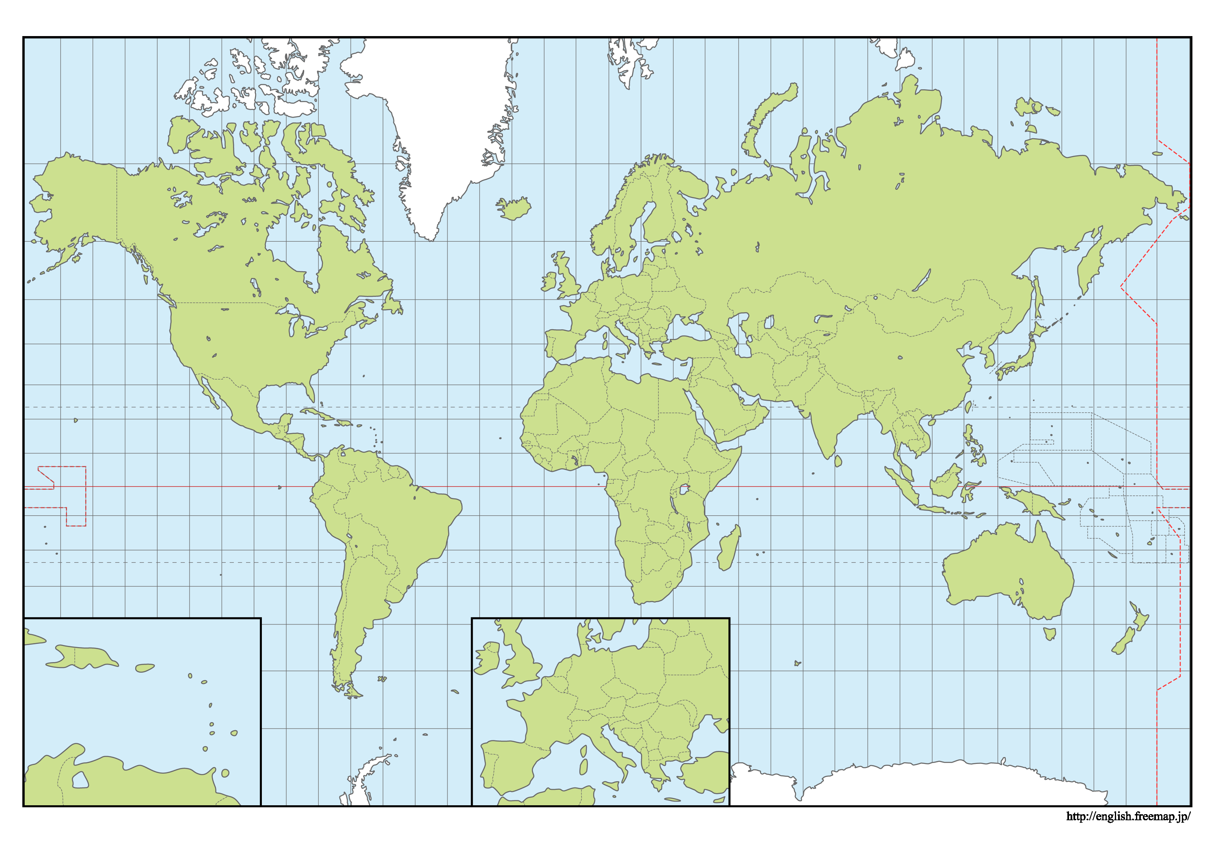
New York
Rio de Janeiro
London
Dubai
Moscow
Cape Town
Ibiza
Tokyo
Sydney

Prices for single fares
 | Cape Town | Dubai | Ibiza | London Heathrow | Moscow | New York | Rio de Janeiro | Sydney | Tokyo
Cape Town |  | £300 | £850 | £700 | £900 | £600 | £550 | £1400 | £1700
Dubai |  |  | £450 | £350 | £250 | £700 | £800 | £600 | £850
Ibiza |  |  |  | £200 | £450 | £600 | £950 | £1100 | £950
London Heathrow |  |  |  |  | £250 | £450 | £500 | £600 | £500
Moscow |  |  |  |  |  | £600 | £700 | £500 | £350
New York |  |  |  |  |  |  | £300 | £1200 | £1100
Rio de Janeiro |  |  |  |  |  |  |  | £1300 | £1200
Sydney |  |  |  |  |  |  |  |  | £500
Tokyo

One possible route is London – Sydney – Rio de Janeiro – New York – Moscow – Ibiza – Cape Town – Dubai – Tokyo – London. But this would cost £6100 and you’d be £600 over budget.

