Packaging

Lots of maths is behind the design of packaging and it is important to be able to decide whether a net will fold up successfully into the shape which you are looking for.

Have a look at the nets of cubes below. How many of them will fold up into a cube?

Number of nets which fold into a cube……………

Cryptography

Lots of mathematics is used in encrypting personal information and it was mathematicians who invented the techniques which keep credit card information safe.

When you write down a long string of digits it is easy to make a mistake and get digits the wrong way round. This could be disastrous when storing important information such as credit card details.

A checking digit can be used to tackle this problem. This is an additional number at the end of the code.
Code
Checking Digit

One way of getting the checking digit is by treating the digits of the code as a number and dividing by 7. Whatever the remainder is will be the checking digit. If the checking digit does not agree with the code, then it is clear that there has been an error. For example in the code 34567 2, 345677 has remainder 1, whereas the checking digit suggests that it should be 2, so this code has an error.

Which of these codes has an error in it?................................................................

Code A 12345 4
Code B 69320 4
Code C 42813 5
Code D 83692 0
Shortest route

Lots of companies want to minimise the distance which their vehicles have to travel in order to cut costs.

Below is the map of a bus network.

A bus driver wants to find the quickest route from Stop A back to Stop A again, calling at all the stops at least once.

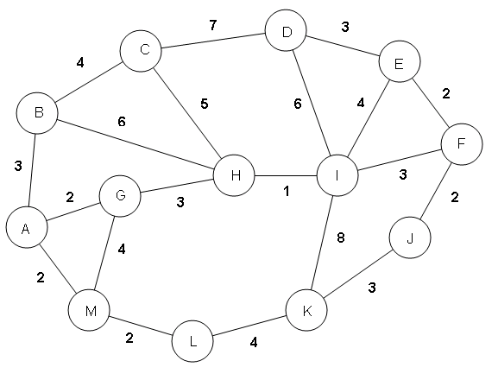

Question: What is the shortest distance possible?...........................................................
Information Calculation

There are lots of situations in the real world where you are only given a limited amount of information and have to work out what is missing.

Asif, Beth and Chris are counting their money.

Asif and Beth together have £5.47
Beth and Chris together have £6.98
Asif and Chris together have £8.53

How much money do they have altogether?.........................

How much do they each have separately? (Hard)

Asif …………………………………..
Beth…………………………………
Chris………………………………….

Tiling Problem

Lots of people use tiling patterns to design driveways, patios and other areas around the home and garden. There is also lots of interesting mathematics relating to Tiling Problems.

How many ways can you tile a 4m × 4m patio with 1m × 2m slabs? Do not include rotations or reflections. So if one pattern is the reflection or rotation of another pattern, we consider them as being the same.

E.g. These two patterns differ only by a rotation, so we would only count them as one pattern.

Use the sheet to help your group sketch possible combinations.

Number of ways of tiling ……………………………………

Logistics Problem

Companies often have to make difficult choices about how to transport goods. Lots of businesses like to employ people with mathematical qualifications to work in their logistics departments.

A haulage company has six crates which it has to distribute evenly between three vehicles.

The crates have the following weights:

35kg, 55kg, 95kg, 115kg, 185kg, 245kg.

Which crates should go into each vehicle in order to make sure that the weight is distributed as evenly as possible? (There are no restrictions with regards to physically fitting the crates into the vans.)

Vehicle A Vehicle B Vehicle C

Business Management

There is so much maths involved in business you would be surprised! See if you can answer the following problem.

Coffee shop business
John needs to decide whether he wants to take on a new coffee shop business. He thinks that he will be able to take home 30% of the total profits each month for his salary.

He estimates that the price of an average coffee will be £2.40 and that his costs (salaries/ equipment etc.) per coffee will on average be £1.80.

If he thinks he can sell 5500 coffees per month, how much salary will he take home?

- What will his profits be per coffee?................

- What will be his total monthly profits?............................................................

- How much will his monthly salary be?........

