Dear Parents / Carers,

I hope this finds you and your loved ones well.

Thank you to all who took the time to respond to our recent home learning survey. Please find below the results, the suggestions made and a plan of how we intend to respond.

A home learning survey was carried out after May half term. 152 parents responded.

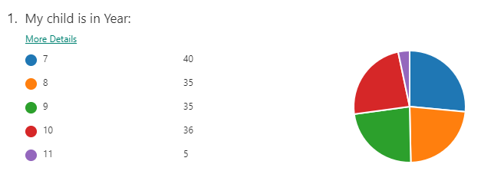 | 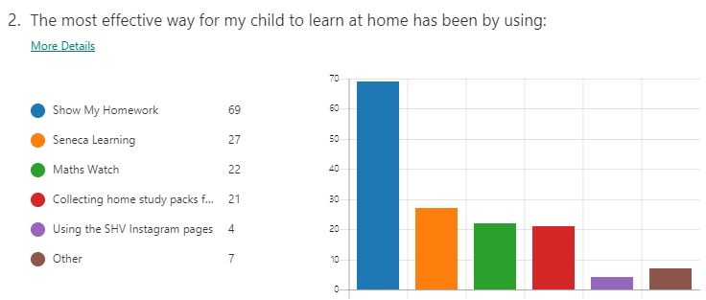
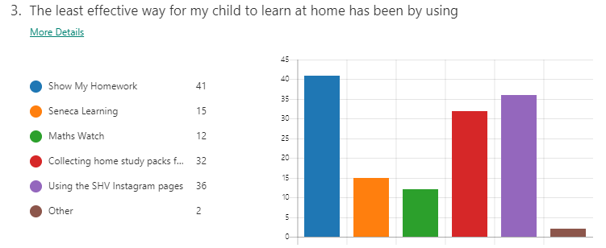 | 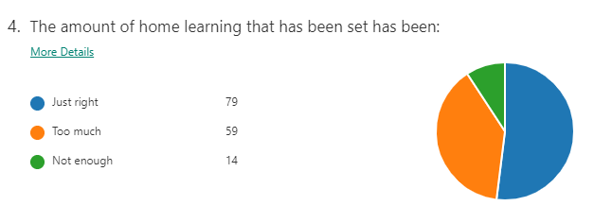
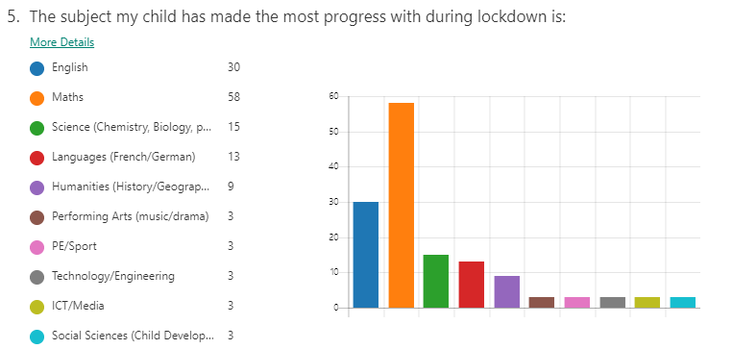 | 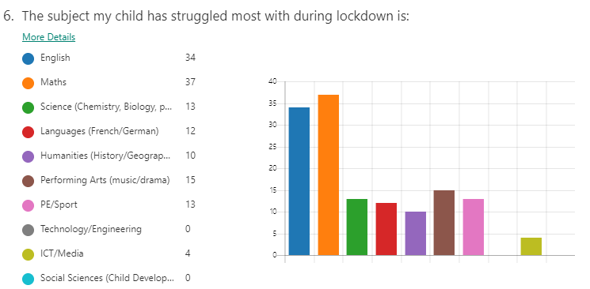
Please let us know how you feel we could improve our support for your child to learn effectively at home for the remainder of the academic year:

This was an open text question but feedback has been classified into the following broad categories:
Issue raised |  | Our response
Technology issues at home/with specific apps | 14 | Phone calls by all tutors to all students to identify specific issues, offer guidance/support/alternatives/.  If you have a missed call from an unknown number it is likely to have been from one of our staff.
Timescales / bulk setting of work (want smaller steps) | 13 | Subject Leaders have been given this information in and are directing staff to set work at a more regular interval, to make steps easier to follow.
Happy with everything-thank you! | 9 | Information passed to staff! Thank you!
Work packs requested | 6 | We print work packs and they are available at school reception. Heads of Year have made many phone calls to check to see if anyone needs one, but if you have been missed, please call the school office and one will be ready and waiting for you to collect.

Issue raised |  | Our response
Online lessons requested | 5 | We are trialing Microsoft Teams with small groups of year 7, 8 and 9 students this week. We will roll this out as and when more staff have been trained.
Phone calls home requested | 3 | Please bear with us, we have made hundreds of phone calls on a weekly basis. If you have missed call from an unknown number, that is likely to have been us. Our phone lines are now open and you can call, text or email to request a call back at a convenient time.
More feedback from teachers requested | 2 | These responses illustrate the difficulty of finding a ‘one size fits all approach’. Information has been passed to subject leaders and pastoral leaders to share with staff so they are aware of individual cases. Subject Leaders are happy to set additional challenges, but we are also mindful that this may overwhelm some students (as below).  Please do not hesitate to contact your child’s Head of Year to request more work or more support if this is needed.
Clearer direction in instructions (say ‘have to work’, not 'could do.’) | 1
More work needed | 1
Too much work to manage at home | 1
Subject specific issue | 1 | Passed on the curriculum leader

Thank you for your continued support, we really do know how challenging it can be! Please do not hesitate to get in touch to let us know if there are any specific ways we can support you and your child to continue their home learning journey in a positive way.
You can contact school by phone or email but the best way to communicate with us is by using the My Ed App, which can be downloaded from the Apple app store or the Google Play app store. This will also give you real time alerts of all school communications. Please contact school if you need support to set this up.
Please rest assured, that as soon as we get more information from the Government about the wider reopening of schools we will be in touch to communicate our plans.
Yours sincerely,

Mrs J Maw
Headteacher

