Year 9 Project

Each week we will be giving you the choice between three mathematics projects. You should email your maths teacher and let them know which project you have completed that week, along with any work you might be able to submit.
Project 1
If you don’t know all of your times tables, here is your chance to learn them! Using times table rockstars learn as many of your times tables as you can. Why not challenge your friends and your teachers? Prizes will be awarded to the top scorer every week.
Project 2
We know a lot of you find telling the time on a clock really tricky. We recommend using the free ‘Maths frame Measuring and Time Resources’.
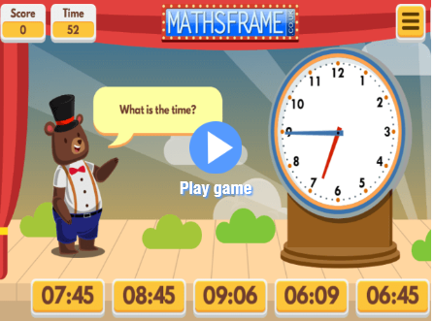
We’d love to hear about your high scores. Please copy your screen and send your results to Mr Wildsmith, who will make sure your high scores appear on Instagram!
Project 3
If you already know your timestables and can tell the time, then project 3 is for you. This week we would have been covering a number topic if we were still at school. As part of this topic you need to be able to:
- Calculate percentages (with a calculator)
We know mathswatch can get busy during the day because so many students are working from home. So to explore this work we recommend you use the ‘hegartymaths’ channel on youtube and search for the topic areas above.
Your challenge is to submit a piece of work showing that you have completed some work on each topic. The best piece of work will receive a prize!

Year 10 Project

Each week we will be giving you the choice between three mathematics projects. You should email your maths teacher and let them know which project you have completed that week, along with any work you might be able to submit.
Project 1
If you don’t know all of your times tables, here is your chance to learn them! Using times table rockstars learn as many of your times tables as you can. Why not challenge your friends and your teachers? Prizes will be awarded to the top scorer every week.
Project 2
We know a lot of you find telling the time on a clock really tricky. We recommend using the free ‘Maths frame Measuring and Time Resources’.
We’d love to hear about your high scores. Please copy your screen and send your results to Mr Wildsmith, who will make sure your high scores appear on Instagram!
Project 3
If you already know your timestables and can tell the time, then project 3 is for you. This week we would have been covering the topic of ‘shape’ if we were still at school. As part of this topic you need to be able to:
- Understand the terms ‘similarity’ and ‘congruence’ and apply them to shapes
We know mathswatch can get busy during the day because so many students are working from home. So to explore this work we recommend you use the ‘hegartymaths’ channel on youtube and search for the topic areas above.
Your challenge is to submit a piece of coursework showing that you have completed some work on each topic. The best piece of work will receive a prize!

