Sandhill View
Computing Curriculum

Achieve Aspire Enjoy
Aim
Here at Sandhill View Academy, we aim to securely equip all of our students for life beyond school as successful, confident, responsible and respectful citizens. We believe that education provides the key to social mobility and our curriculum is designed to build strong foundations in the knowledge, understanding and skills which lead to academic and personal success. We want our students to enjoy the challenges that learning offers.
Our aims are underpinned by a culture of high aspirations. Through developing positive relationships, we work towards every individual having a strong belief in their own abilities so that they work hard, build resilience and achieve their very best.
Intent
The curriculum includes formal teaching through subject areas, assemblies and extracurricular activities. We regularly review content to ensure we continue to meet our curriculum aims. The ICT, Business Studies and Computing curriculum is planned to enable all students to develop:
- Exceptional problem solving skills
- A High level of competency in regards to computer skills
- Basic knowledge of the difference between ICT and Computing
- Business Studies knowledge to help understand the way businesses work in real-life situations
- Passion for the curriculum and interest in future careers in the relevant industries

Throughout our programmes of study, every attempt is made to make explicit links to careers and the world of work. In addition to subject specific links, we aim to explicitly reinforce the skills and aptitudes which support employers say are important in the workplace;

- Resilience (Aiming High, Staying Positive, Learning from Mistakes)
- Collaboration (Teamwork Leadership Communication)
- Creativity (Originality, Problem Solving, Independent Study)

The British values of democracy, the rule of law, individual liberty, and mutual respect of those with different faiths and beliefs are taught explicitly and reinforced in the way in which the school operates.

Sequence and structure

Our curriculum is split in to Key Stage 3 (years 7 and 8) and Key Stage 4 (years 9, 10 and 11). Whereas we have condensed the traditional KS3 into two years, we have lengthened the school day. This gives ample opportunities for coverage of all subject areas within the national curriculum, and others which we believe reflect the needs of the community we serve.

Our Key Stage 3 Curriculum includes the following areas:
Year 7

Word processing and beyond

In this section, the students are given an introduction into the main purposes of basic software used in an office environment. Things such as:
- What is the purpose of presentation software?
- What is a hyperlink and why might it be used in a presentation?
- What are folders and sub-folders and why are they important?
- What makes a bad document using desktop publishing software?

This is a vital stage of the students Computing education as it gives them the basics of how to use the computers and how to organise their work.
Spreadsheets

In this unit, the students study the basics of using Microsoft Excel in order to model a spreadsheet. They look in detail at what is meant by the term ’modelling’. Once they have looked at this they then go on to develop their understanding of how to format a spreadsheet, use cell references, use basic formulas to some extent and, finally, evaluate the importance of a spreadsheet in different circumstances.
Some of the aspects of spreadsheets they learn about include:
- Cell referencing
- Formulas
- Formatting
- Data types
Data Representation

In this unit, we take an insight into how databases are used in everyday life and well as looking at the definition of a database. We look at what makes a successful database and what type of ‘data type’ should be used in different situations.
The design of a database is important and we teach the students the best format and layout for a professional database,
Some of the topics covered in this topic include:
- Fields
- Records
- Data Types
- Key Fields
- Validation
- Queries

Computer Architecture

Computer architecture is a new topic, has recently been added to the department curriculum. Here we look at the basics of how computers are structured and the layout of different architectures. This is a clear step towards a more Computing based KS3 curriculum, opposed to a more ICT based one.
Here the students look at the internal components of a computer instead of the external input and output devices.
Some of the topics covered in this unit are:
- Hardware and Software
- Input and Output Devices
- CPU
- Networks

Website Development

This is the students’ first introduction to computer programming. Here they learn at the HTML computer programming language and what it is used for. The students learn the basics of using tags in notepad++ before saving the document with the correct file type in order to be able to open the programming code as an actual web page.
The topics covered in this section of KS3 include:
- Tags
- File formats
- HTML
- Formatting a web page

Year 8
Online communication

In this unit, the students develop their understanding regarding how the modern world uses computers in order to communicate. We take an in-depth look at what makes a reliable website, and how we can determine if a website is unreliable. The students learn the basics of Boolean logic, and how this is used with search engines.
We then go on to look at the advantages and disadvantages of using the internet for people from different demographics.

HTML

This is the second time we visit the HTML topic and look at webpage development.
In this section, we look at how to input images onto a webpage and edit the size and resolution of the images in order to make the webpage look professional and have good loading times. The webpages are then linked together with a basic navigation bar and hyperlinks.

Programming techniques (python)

The students further develop their programming skills in this section of the curriculum. They look into the different uses of python and what the basics of the python language are.
The topics covered in this topic include:
- # comments
- The print statement
- Annotating sections of code
- Debugging
- Variables
- Programming constructs

Computer connections & processing and hardware
Students look at how computers consist of input and output devices. We look at different devices that connect to a computer and the individual uses of each. We also look at the internal components of a computer. Things such as;
- CPU
- Fan
- RAM
- ROM
- Memory
- Motherboard

We also take brief look into different connection methods (wired and wireless), as well as, embedded systems.

We know that students who read well achieve well. As such all subject areas are committed to providing regular opportunities to read extensively. We provide regular opportunities for students to read for pleasure and to receive small group interventions if their reading skills are lower than we would expect.

Our Key Stage 4 Curriculum includes the following qualification choices:

At Key Stage 4 it is compulsory for every student to complete their GCSE in Creative iMedia with the OCR exam board. We also offer Computing GCSE to Year 10 and 11 students with the AQA exam board:

Year 9

OCR Creative iMedia GCSE
KS 4 | Half Term 1 | Half Term 2 | Half Term 3 | Half Term 4 | Half Term 5 | Half Term 6
Year 9 | R082: Creating Digital Graphics:  Here the students are required to investigate the different uses of Digital Graphics. They then have to apply this knowledge when creating their own DVD cover. This then has to be evaluated. | R087: Interactive Multimedia Product:The students have to research different interactive products and assess their uses under different circumstances. They then apply this knowledge when creating their own information kiosk. This is then evaluated. | R087: Interactive Multimedia Product:  The students have to research different interactive products and assess their uses under different circumstances. They then apply this knowledge when creating their own information kiosk. This is then evaluated. | R089: Digital video:  Students research different uses of digital videos in different industry sectors. They are then required to plan their own digital video from the perspective of a freelance journalist. | R089: Digital video:  Students research different uses of digital videos in different industry sectors. They are then required to plan their own digital video from the perspective of a freelance journalist. | R081: Pre-production skills:  Students cover all of the content for the first attempt they have at the exam unit in January
OCR Enterprise and Marketing
KS 4 | Half Term 1 | Half Term 2 | Half Term 3 | Half Term 4 | Half Term 5 | Half Term 6
Year 9 | Unit R064 Enterprise and marketing concepts  Learning Outcome 1: Understand how to target a market | Unit R064 Enterprise and marketing concepts  Learning Outcome 2 Understand what makes a product or service financially viable | Unit R064 Enterprise and marketing concepts  Learning Outcome 3: Understand product development | Unit R064 Enterprise and marketing concepts  Learning Outcome 4: Understand how to attract and retain customer | Unit R064 Enterprise and marketing concepts  Learning Outcome 5: Understand factors for consideration when starting up a business | Unit R064 Enterprise and marketing concepts  Learning Outcome 6 Understand different functional activities needed to support a business start-up

Year 10

At Key Stage 4 students follow the OCR exam board.

Half-term 2 | Half-term 3
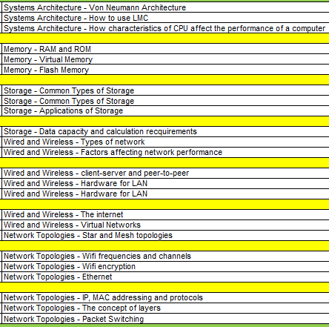 | 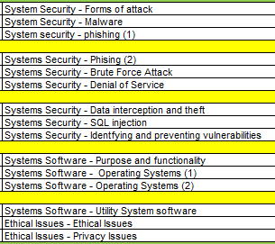
Half-term 4 | Half-term 5
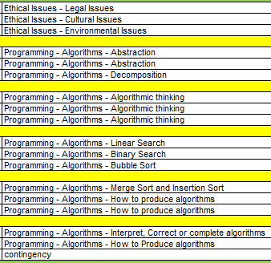 | 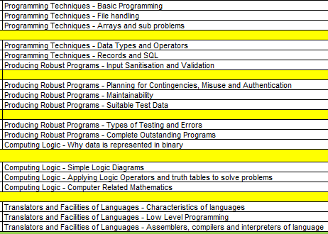
Half-term 6
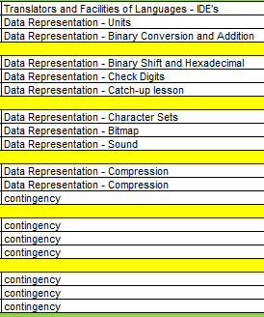

OCR Enterprise and Marketing
KS 4 | Half Term 1 | Half Term 2 | Half Term 3 | Half Term 4 | Half Term 5 | Half Term 6
Year 10 | Unit R065 Design a business proposal  Learning Outcome 1: Be able to identify the customer profile for a business challenge | Unit R065 Design a business proposal  Learning Outcome 2: Be able to complete market research to aid decisions relating to a business challenge | Unit R065 Design a business proposal  Learning Outcome 3: Be able to develop a design proposal for a business challenge | Unit R064 Enterprise and marketing concepts  Learning Outcome 4: Understand how to attract and retain customer | Unit R065 Design a business proposal  Learning Outcome 4: Be able to review whether a business proposal is viable | Unit R065 Design a business proposal  Learning Outcome 4: Be able to review whether a business proposal is viable

For more information about the specific details of our curriculum, please refer to the subject specific pages of our website.

How does our Curriculum cater for students with SEND?

Sandhill View is an inclusive academy where every child is valued and respected. We are committed to the inclusion, progress and independence of all of our students, including those with SEN. We work to support our students to make progress in their learning, their emotional and social development and their independence. We actively work to support the learning and needs of all members of our community.
Teachers are responsible for the progress of ALL students in their class and high-quality teaching is carefully planned; this is the first step in supporting students who may have SEND. All students are challenged to do their very best and all students at the Academy are expected to make at least good progress.

Specific approaches which are used within the curriculum areas include:
- Seating plans are used to minimise the disruption in lessons and to optimise the support available.
- Resources well organised and up-to-date
- Displays and visual learning tools are used where necessary
- Where appropriate support from additional adults is planned to scaffold students learning
- Groups work and discussion
- Clear teacher/student communication.
- Feedback that allows students to make progress, whether written or verbal
- Independent study/homework;
- Reduce the reliance on memory and embed a deeper understanding of Computer Science.

How does our curriculum cater for disadvantaged students and those from minority groups?
As a school serving an area with high levels of deprivation, we work tirelessly to raise the attainment for all students and to close any gaps that exist due to social contexts. The deliberate allocation of funding and resources has ensured that attainment gaps are closing in our drive to ensure that all pupils are equally successful when they leave the Academy.
Approaches in Science include:
- We use intervention effectively to ensure that all students are given the opportunity to succeed
- Disadvantaged students are identified, and computing resources are available to them during after-school homework and intervention sessions
- We have a number of trips and after-school clubs which run each year which give all students the opportunity to develop their understanding and interest in Computing.

How do we make sure that our curriculum is implemented effectively?
The Science curriculum leader is responsible for designing the Science curriculum as well as subsequent monitoring and review.
The Subject Leader’s monitoring is validated by senior leaders.
Staff have regular access to professional development/training to ensure that curriculum requirements are met.
Effective assessment informs staff about areas in which interventions are required. These interventions are delivered during curriculum time to enhance pupils’ capacity to access the full curriculum.
Curriculum resources are selected carefully and reviewed regularly.
Assessments are designed thoughtfully to assess student progress and also to shape future learning.
Assessments are checked for reliability within departments and across the Trust.
GAP analysis is used throughout the assessment process. This then helps us to identify the students who are most in need of intervention sessions.
There is frequent contact with exam boards (OCR and AQA) to ensure that the relevant and up to date content, courses and topics are being taught across all key stages.
We have links to companies in the Computing sector through our working relationship with Sunderland Software Centre. We have attended Tech Sector Day where the GCSE Computer Science students met with local providers to build their understanding of how the skills, they are learning can be applied in everyday jobs.
We also have a direct link with AM3D, a 3D printing company based in Washington, Sunderland. The team from AM3D are coming into school to show the students how to print in 3D, this is an excellent way to enhance the knowledge of the students in an upcoming and relevant field.
There are a group of GCSE Computing students who are currently competing in the Airgeneers scheme which is being run in collaboration with Nissan. In this scheme, the students must build their own drones and program the drones to make them fly as efficiently as possible. We then have a team of students who will attend the final of the competition in July to see which team can fly their drone around an assault course the fastest. This will be competing against other schools in the area.

How do we make sure our curriculum is having the desired impact?
- Examination results analysis and evaluation
- Analysis of destination measures
- Analysis of attendance data
- Analysis of pastoral data
- Termly assessments-analysis and evaluation meetings
- Lesson observations
- Learning walks
- Book scrutiny
- Regular feedback from Teaching Staff during department meetings
- Regular feedback from Middle Leaders during curriculum meetings
- Pupil Surveys
- School council meetings
- Parental feedback

