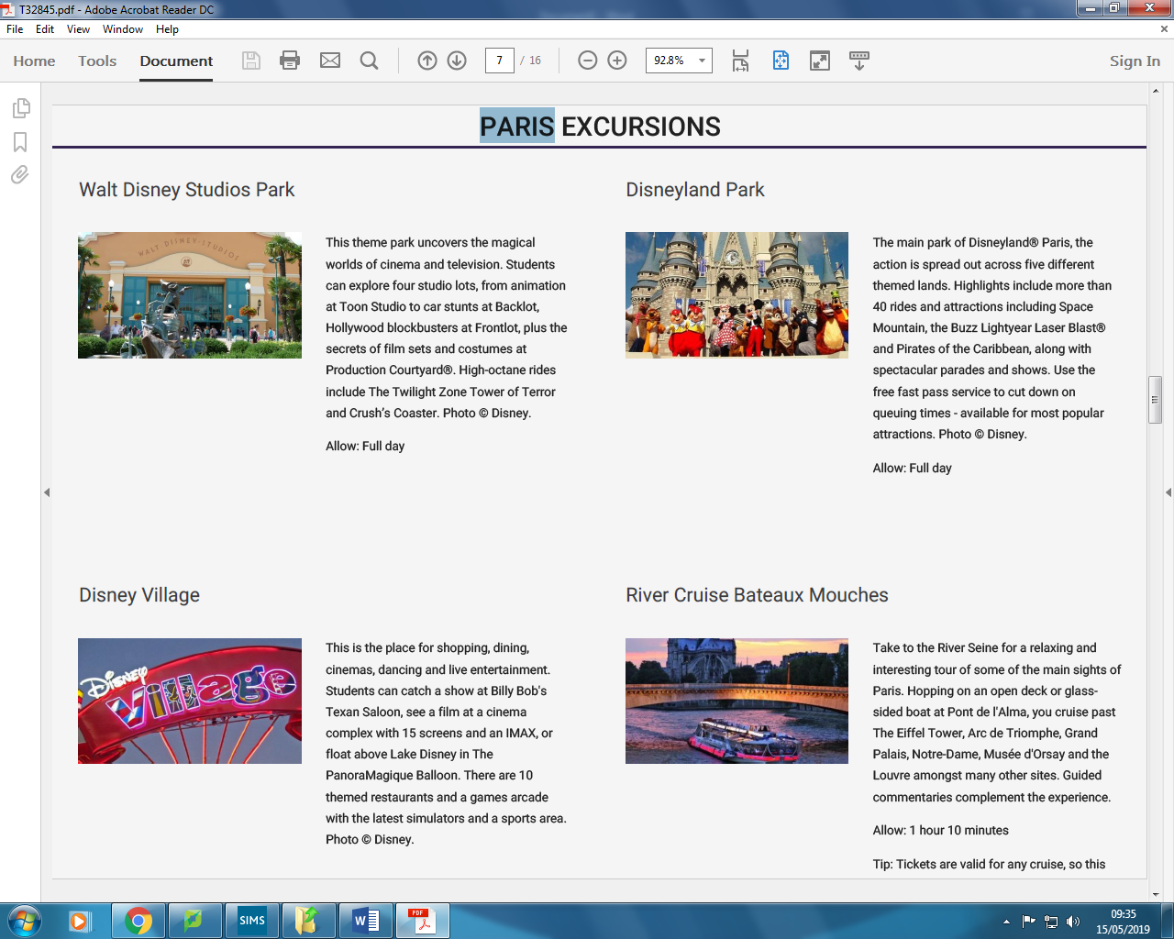 **Château and Paris Tour**



Visit the main park of Disneyland Paris, where the action is spread out across five different lands. Highlights include 40 rides and attractions and fast pass service to cut down queuing times.

This theme park uncovers the magical worlds of cinema and television. Students can explore four studio lots, from animation at Toon Studio to car stunts at Backlot, Hollywood blockbusters at Frontlot and secrets of film sets and costumes at Production Courtyard

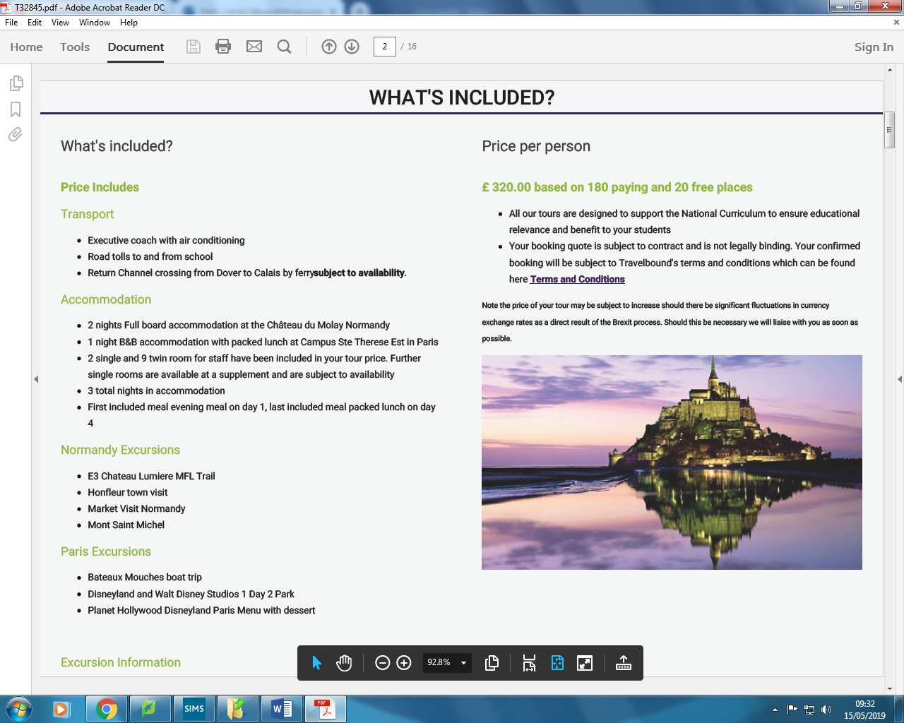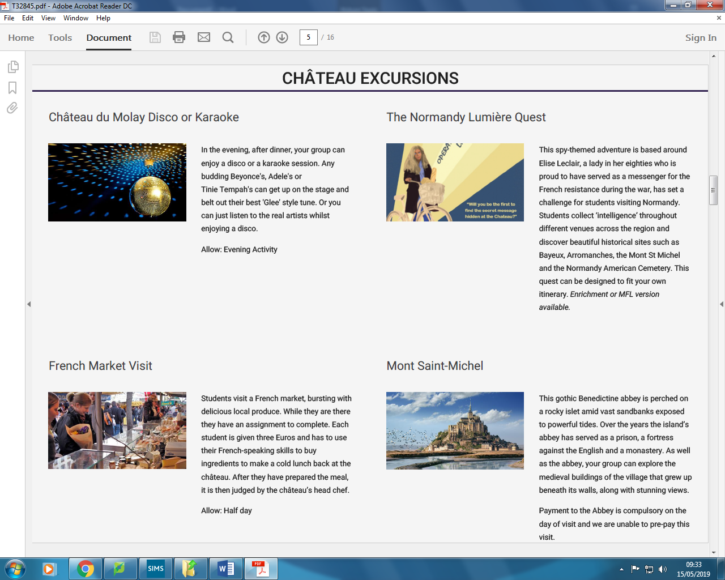

This is the place for shopping, dining, cinema and live entertainment. Students can catch a show at Billy Bob’s Texan Saloon, see a film at the cinema complex or float above Lake Disney. There are 10 themed restaurants and games arcade with the latest simulators and sports area.

Take a relaxing tour down the River Seine for relaxation and view of the main sights of Paris. Hopping on an open deck or glass sided boat at Pont de I’Alma, you can cruise past the Eiffel Tower, Arc de Triomphe, Grand Palais, Notre-Dame and the Louvre.

Mont Saint-Michel is a gothic Benedictine abbey, perched on a rocky islet amid vast sandbanks and exposed to powerful tides. Over the years the island’s abbey has served as a prison, a fortress against the English and monastery. Students can explore the medieval buildings.

French market visit allows students to experience local produce. Students complete a three Euro challenge of who can purchase ingredient to make a cold lunch back at the Château.