19th June 2019

Dear Parent/Carer

I would like to advise you of a small price increase of 10p to our school meals which will come in to effect in September 2019.

There has been no increase to our prices for the last 2 years which has mainly been due to funding, however as a result to a reduction in funding and rising food costs it has become necessary to increase the price of a school meal from £2.20 to £2.30 for September 2019.

It should be noted that a school meal still provides excellent value for money with prices amongst the lowest in the region and across the country, and all of our students thoroughly enjoy the range of food provided.

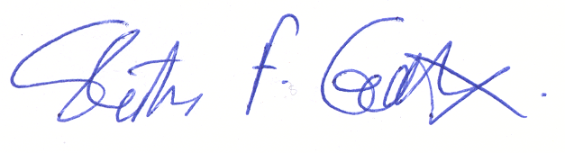
Yours sincerely

Steve Garrett
Chief Executive Officer

