Used the platform before?  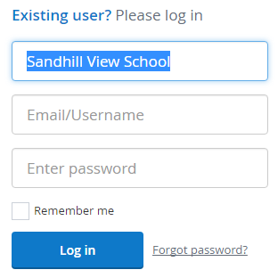  Go to the address: www.showmyhomework.co.uk/login  and enter your login details. The school name should be typed as shown above. | NOT used the platform before?  Go to the address: www.showmyhomework.co.uk/login  then click on the ‘I have been given a PIN or PARENT CODE link:  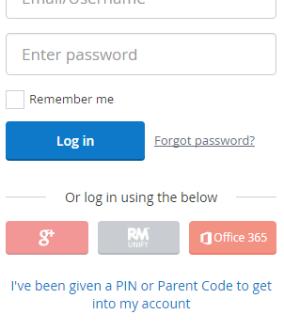
You will be asked to register some details so that you can receive notifications when homework is set/completed etc. | By selecting the ‘Homework’ menu, you are able to see, in date order, all of the homework that has been set for your child. Furthermore, you can filter the homework to see if any is now overdue.
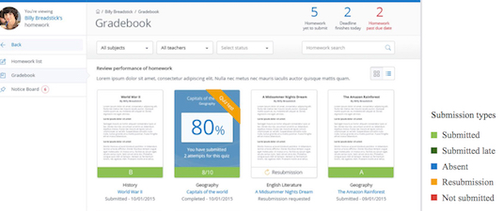  By selecting ‘Gradebook’ you are able to see your child’s performance in any formally marked pieces of homework. | Downloading the app will allow you to receive notifications to your smartphone.  You can be notified when homework is set, submitted and marked.  As well as this, you are able to post comments to staff if you have any queries regarding the homework set.

