Breakfast Menu

Muffins 80p

Waffles 60p

Cereal with Milk 70p

Porridge 70p

Croissants 60p

Assorted Biscuits 40/60p

Milk 35p

Crumpets 30p Each

Toast with Butter 30p per Slice

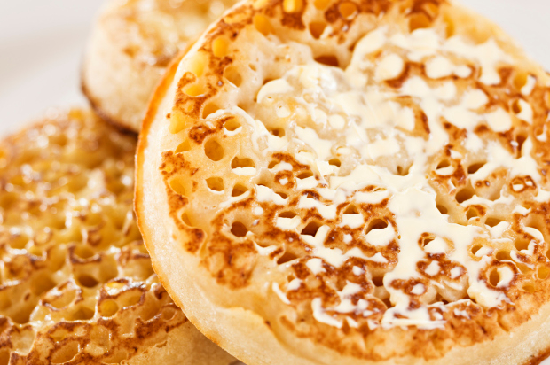

Choco au Pain 60p